

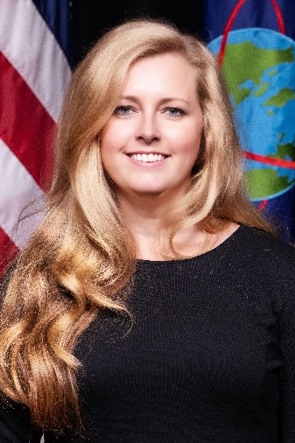

**BROOKE N. STEWART**

Intelligence Directorate Executive Data Officer and Chief of the Data Management & Engineering Branch,   
Advanced Analytics, Artificial Intelligence, and Machine Learning (A³IM) Division,

United States Central Command (USCENTCOM) Directorate of Intelligence (J2)

Ms. Brooke Stewart currently serves as the Intelligence Directorate Executive Data Officer and Chief of the Data Management & Engineering Branch for the Advanced Analytics, Artificial Intelligence, and Machine Learning Division, CCJ28, USCENTCOM, MacDill Air Force Base, Florida. In this role, she maintains the Directorate Data Strategy, Data Management Processes, Standards, and Governance policies. She is responsible for integrating CCJ2 data holdings and ensuring accessibility to CCJ2 JWICS cloud architectures. Ms. Stewart oversees the implementation of the Maven Smart System (MSS) and ADVANA platforms, fostering a culture of communication and collaboration among J2 personnel. Ms. Stewart's expertise guides the USCENTCOM Directorate of Intelligence in leveraging data and data-science innovatively, achieving data-centric, data-driven solutions through advanced analytic methods, emerging technologies, and the integration of machine learning (ML).

Over her 22 years of government service as a DIA civilian and U.S. Army professional, Ms. Stewart has held various positions, including a deployment to ISAF HQ in Afghanistan. Within USCENTCOM J2, she has served as Trans-Regional Department Integration Branch Chief, CCJ2 Freedom of Information Act (FOIA) and Information Release Officer, CCJ22 Knowledge Management Chief, CCJ2 Foreign Disclosure Officer, CCJ2 Software Engineer, and Information Technology Specialist.

Brooke holds two Master's degrees, the first from Troy University in International Relations with a focus on National Security, and the second from the USAF Air Command and Staff College in Military Operational Art and Science. Currently, she is furthering her professional development through the University of South Florida's Data Analytics Course, gaining expertise in Excel, SQL, Python, Microsoft BI, Tableau, data integration, and AI/ML systems.

Outside of her professional pursuits, Ms. Stewart enjoys exploring Florida through kayaking, hiking, and visiting Disney World and Universal Studios. In addition to her hobbies, she is a dedicated foster parent for Hillsborough County, providing support to children ranging from newborns to 17-years-old. Brooke's busy life is enriched by her three dogs, Vesper, Thomas, and Bogan, and a cat named Julep, who keep her entertained and fulfilled.